**A**

**Project Report**

**On**

**"Website Using Bootstrap & Prototyping Electronics with Arduino"**

(CE346 – Summer Internship-1)

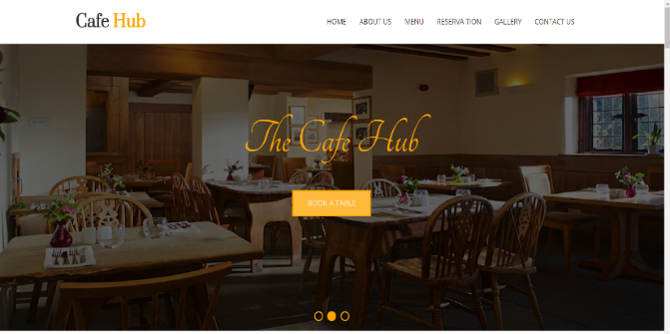 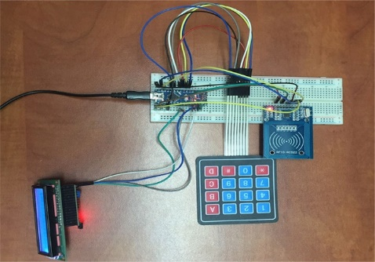

**Prepared by**

Tarun S. Adavani(16CE002)

Shivam J. Bhanvadia(16CE008)

**Under the Supervision of**

Mr. Keyur Garala

**Submitted to**

Charotar University of Science & Technology (CHARUSAT)

for the Partial Fulfillment of the Requirements for the

Degree of Bachelor of Technology (B.Tech.)

in Computer Engineering (CE)

for 5th semester B.Tech

**Submitted at**



**Accredited with Grade A by NAAC**

**Accredited with Grade A by KCG**



**U & P U. PATEL DEPARTMENT OF COMPUTER ENGINEERING**

**(NBA Accredited)**

**Chandubhai S. Patel Institute of Technology (CSPIT)**

**Faculty of Technology & Engineering (FTE), CHARUSAT**

**At: Changa, Dist: Anand, Pin: 388421.**

**June, 2018**

**DECLARATION BY THE CANDIDATES**

We hereby declare that the project report entitled “**Website Using Bootstrap & Prototyping electronics with Arduino**” submitted by us to Chandubhai S. Patel Institute of Technology, Changa in partial fulfilment of the requirement for the award of the degree of **B.Tech** in Computer Engineering, from U & P U. Patel Department of Computer Engineering, CSPIT/FTE, is a record of bonafide **CE346 Summer Intership-1** carried out by us under the guidance of **Mr Keyur Garala**. We further declare that the work carried out and documented in this project report has not been submitted anywhere else either in part or in full and it is the original work, for the award of any other degree or diploma in this institute or any other institute or university.

Tarun S. Adavani(16CE002)

Shivam J. Bhanvadia(16CE008)

Mr. Keyur Garala

HR, Head of Web development dept.

**COMPANY CERTIFICATE**

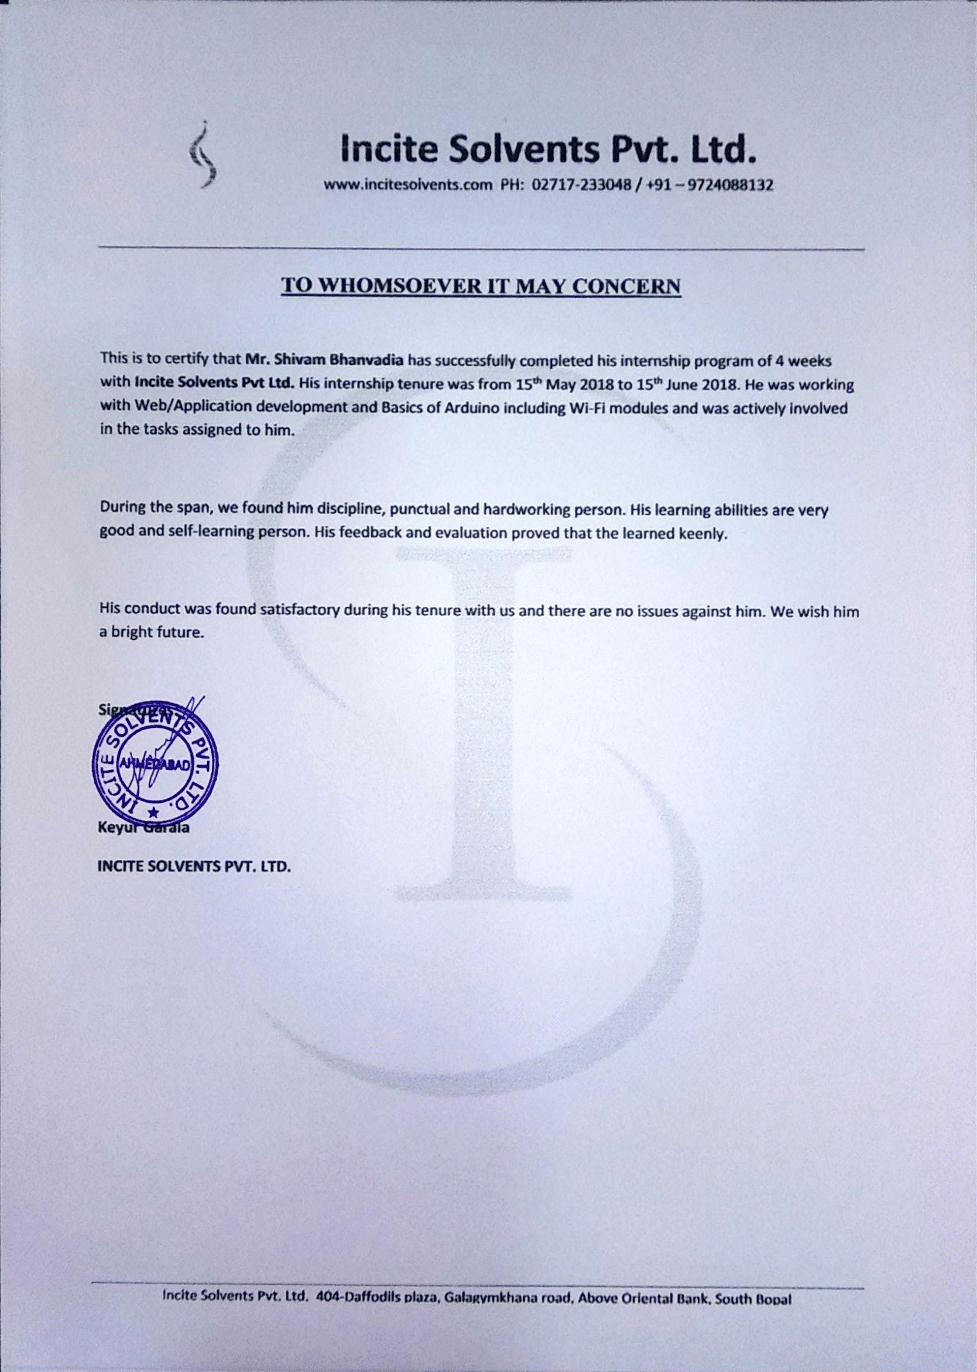

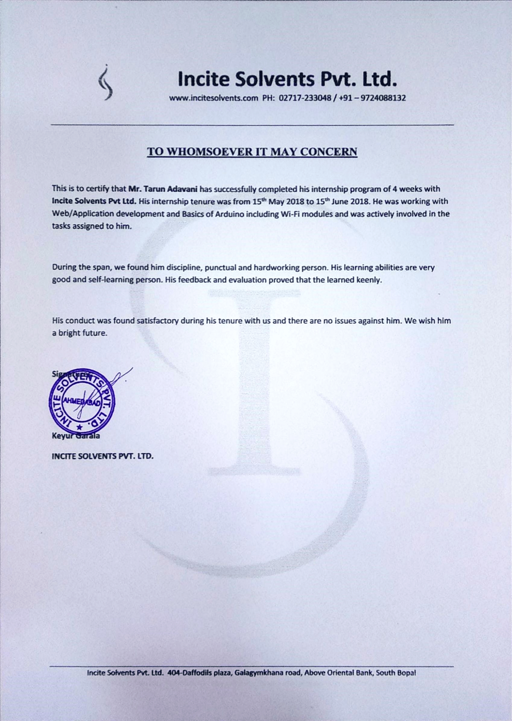

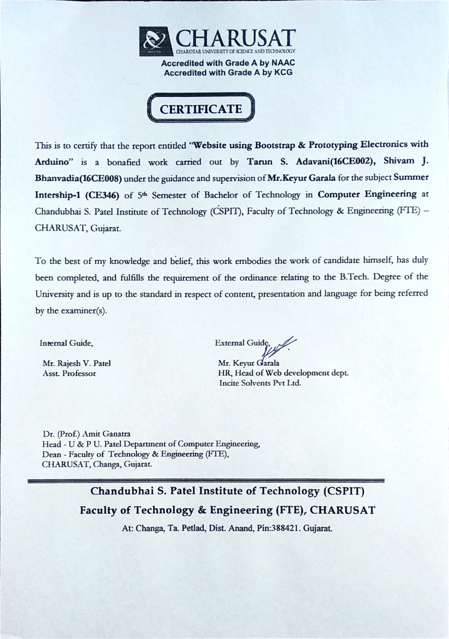

**ABSTRACT**

Summer Internship/Training is an integral part of the CE (B.Tech) program. The objective of such an exercise is to get a first-hand exposure to the realities of the IT segment and gain an insight into the working of the corporate world and develop technical and communicational skills. The summer training gives an opportunity to become aware of the student’s strengths and weakness as required for potential IT experts.

It has been observed that practical knowledge plays a vital role than the theoretical knowledge. This is so because practical knowledge gives chance to express our own ideas, way of thinking and different thoughts.

The project allotted to us by our guide at INCITE SOLVENTS PVT LTD. was “Website using Bootstrap & Prototyping electronics with Arduino”. The first part of the report comprises of Organization details which includes all the information of company profile, tasks performed at the organization, learning from organization and the second part consists of the project study.

The project study was carried on topic of “Website using Bootstrap & Prototyping electronics with Arduino” for Incite Solvents Pvt Ltd.(Gujarat) located in Ahmedabad. The project includes making a website for the firm using bootstrap which can be easily modified by the administrator. It also includes making the website user friendly and attractive. The website has a reservation table facilities, pre-ordering the menu. And with this we have also made a design of digital door lock using Arduino and worked on Wi-fi module(esp8266).

**ACKNOWLEGEMENT**

With immense pleasure, We would like to present this project report on “**Website using Bootstrap & Prototyping electronics with Arduino**” for Incite Solvents Pvt Ltd. at Ahmedabad. It has been an enriching experience for us to undergo our summer training at Incite Solvents Pvt Ltd., which would not have possible without the goodwill and support of the people around.

As a student of Chandubhai S Patel Institute of Technology(CSPIT), We are highly thankful to **Dr. Amit Ganatra** (Dean of Technology Department CSPIT, Charusat University, Changa.) who allowed us for this project at Incite Solvents Pvt Ltd.

We would like to give our heartily thanks to Mr. Keyur Garala who guided us and support throughout the project. Without them we would not be able to complete this project successfully. We are very thankful to whole staff who helped us at every step whenever needed.

We sincerely thanks to our faculty guide Mr. Rajesh V. Patel, for providing understanding on the ways of preparing a project report and for the guidance and support for Summer Training.

Lastly, We convey our regards to the whole staff, which made our stay at INCITE SOLVENTS PVT LTD., a memorandum part of life.

**TABLE OF CONTENTS**

|  |  |
| --- | --- |
| **Chapter**  **No.** | **Title** |
|  | **PART I – COMPANY PROFILE** |
| **1** | Introduction |
| **2** | The Company / Organisation   * Evolution and History * Mission and Vision * Governance / Management Structure * Products * Geographical spread of facilities |
| **3** | Tasks and Activities performed at the organisation |
| **4** | Learning Experience (Novelty and originality of works) |
|  | **PART – II – PROJECT STUDY** |
| **5** | Overview of the Project   * Background of the study * Importance of the study to the organisation * Objectives of the study * Tools and Technology description * System Flow chart * Screenshots |
| **6** | Conclusions and Limitations |
| **7** | Applications |
| **8** | References |

**LIST OF FIGURES**

|  |  |  |
| --- | --- | --- |
|  | **Title** | **Page No.** |
| Fig. 1 | Governance/Management Structure | **12** |
| Fig. 2 | Geographical Spread of Facilities | **13** |
| Fig. 3 | System Flowchart | **17** |

**LIST OF TABLES**

|  |  |  |
| --- | --- | --- |
| **Serial No.** | **Title** | **Page No.** |
| 1 | Introduction | **10** |
| 2 | Tasks and Activities Performed | **14** |

**PART I – COMPANY PROFILE**

**1. INTRODUCTION**

|  |  |
| --- | --- |
| **NAME OF THE COMPANY** | “**INCITE SOLVENTS PVT LTD.”** |
| **ADDRESS** | 404, Daffodils Plaza, Above Oriental Bank, Gala Gymkhana Road, South Bopal, Ahmedabad.  (Gujarat) |
| **TELEPHONE** | (02717)233048/ +91-9724088132 |
| **E-MAIL** | [keyur.garala@incitesolvents.com](mailto:keyur.garala@incitesolvents.com) |
| **LOCATION** | 20km from Railway Station |
| **NATURE OF THE COMPANY** | The nature of company is Web Development. |
| **TYPE OF THE COMPANY** | Private Limited Company |
| **MAIN BUSINESS** | Main business of the company is developing websites for clients. |
| **DEVELOPMENT AREAS** | Site core, DotnetNuke, AngularJS |

**2. THE COMPANY/ ORGANISATION**

**2.1 EVOLUTION AND HISTORY**

Incite Solvents Pvt Ltd. has been developing websites, IOT switches and android application software for the last 5-6 years, having acquired a respectable clientele in the country. Apart from working on AngularJS and Android, the company also works on Word press, DotNetNuke, IOT. The company has developed websites for some of the reputed firms like Phoenix media labs in Gujarat.

The company has a well-equipped lab for developing websites and software as per the clients’ needs. Our objective today is under scored as developing user-friendly mobile-friendly efficient websites and software which provide flexibility of operating from computers as well as mobiles to the user.

**2.2 MISSION AND VISION**

* **VISION OF THE COMPANY**

To maintain a pleasant workplace at all times and encourage employees.

To augment the growth of our clients with superior site development and creative designs.

* **MISSION AND VALUES OF THE COMPANY**

We Believe in the quality,

We add values.

To expand our company throughout Gujarat and provide statewide internet solutions.

**2.3 GOVERNANCE/ MANAGEMENT STRUCTURE**

**CHAIRMAN & MANAGING DIRECTOR**

Mr. Keyur Garala

Mr

**GENERAL MANAGER**

Mr. Bhavin Garala

**WEB DEVELOPMENT HEAD**

Keyur Garala

**HARDWARE**

**INTERFACE**

Kaushal Patel

**HUMAN RESOURCE -MANAGER**

Keyur Garala

**2.4 PRODUCTS**

* Web/Mobile app using ionic frameworks
* E-Commerce websites
* Word Press customized websites
* Android and iOS applications
* IOT switches

**2.5 GEOGRAPHICAL SPREAD OF FACILITIES**

The company has not specification of segmentation, but there is specification of target market as area wise like in abroad. We are backed by a team of sincere and dedicated professionals, which helps us develop and deliver optimum websites. These professionals are experienced and well versed in their domains and work meticulously in their respective fields in order to offer quality products to our clients. Their cooperation has made it possible for our organization to attain prominence in the industry.

**3. TASKS AND ACTIVITIES PERFORMED AT THE ORGANISATION**

As our work began from 15th May, We were assigned to work with the other employees at Incite Solvents Pvt Ltd. during work hours from 10am to 4pm. As a test of our knowledge, we were assigned the following tasks:

|  |  |  |
| --- | --- | --- |
| **TASK ALLOCATED** | **TASK COMPLETED** | **LEARNING** |
| To develop an application form with validation. | Yes | Learn form validation through JS. |
| To convert a static template into a dynamic website with reservation table booking and pre-order webpage functionalities. | Yes | Learn the core features of bootstrap, JS. |
| To code a C program with Arduino which design a door lock system which would unlock only when the 4-digit correct password will typed in the matrix keypad else it wouldn’t open the door. | Yes | Designing the door lock using some crucial components with virtual connections. |
| To switch on/off the lights using Wi-fi module(esp8266). | Yes | Working of Wi-fi module. |

**4. LEARNING EXPERIENCE (NOVELTY AND ORIGINALITY OF WORKS)**

It was our pleasure to work in a web and software development company as an intern in Incite Solvents Pvt Ltd. It was a great learning experience, which gave me an overview of the organization, its services, its policies, and steps taken to optimize its products. Moreover, we got a clearer picture about the role played by the organization in the market and the problems faced. We came to know more about web designing and Arduino. This study not only gave me factual knowledge but also confidence and the way to interact with people in the organization. we got an opportunity to work for a company and to know how an IT company actually works.

It gave us a more independent way of thinking about the problems faced in this IT sector and solutions towards to it. As a whole, it was a great learning experience and it was my pleasure to work in this organization. We thank our Dean (Principal) of CSPIT who gave the opportunity for internship.

Declaration of Originality:

For this internship I, Shivam J. Bhanvadia and I, Tarun S. Adavani were provided a template by the company and all our work there on has been performed by us only and we **confirm** that it is **original**.

**PART – II – PROJECT STUDY**

**5. OVERVIEW OF THE PROJECT**

**5.1 BACKGROUND OF THE STUDY**

Developing a website is a priority these days to your business on the Internet. Designing and Development are the steps that are **important.** Bootstrap allows you to give a very good templates and your website looks very creative and efficient designed. PHP is one the language used to make such amazing website dynamic.

Wi-fi modules was used to switch on/off light to using sending data.

**5.2 IMPORTANCE OF THE STUDY TO THE ORGANISATION**

Making a database-connected website has a lot of hindrances, let alone a truly fully functional user-friendly one. Every website has to be checked multiple times thoroughly to ensure its complete functionality.

This project handed to me by Incite Solvents Pvt Ltd. was a part of a website requested by a client of our company. The website is connected to a local database. The designing of the website was undertaken to comply the needs of the client. The mere text content will be altered by the company according to the client’s request and then put online.

**5.3 OBJECTIVES OF THE STUDY**

* To make an application form with the help of HTML, JS.
* To create a website using the given template.
* To provide a table reservation facilities at first.
* Apply the concepts of CSS to make the website attractive.
* To provide local database connectivity using MySQL and WampServer.
* To understand the working of an IT company.
* To develop communicational skills by interacting with the company executives.
* To develop a user-friendly and efficient website using the aforementioned tools.
* We used Wi-fi module to send data in heterogeneous environment.

**5.4 TOOLS AND TECHNOLOGY DESCRIPTION**

Incite Solvents Pvt Ltd. is well-equipped with professional level computers. All the computers at the company run at 8 GB of RAM and operate on Windows10.

The following tools and technology were used in the project study:

**Machine:**

A Windows-based computer

**Scripting and other languages:**

* HTML
* CSS
* JS
* Bootstrap
* PHP

**Coding software:**

* Notepad++
* Sublime Text
* Atom io
* Arduino IDE

**PHP stack software:**

* WampServer

**Circuit Designing software:**

* ISIS

**5.5** **SYSTEM FLOWCHART**

**5.6 SCREENSHOTS**

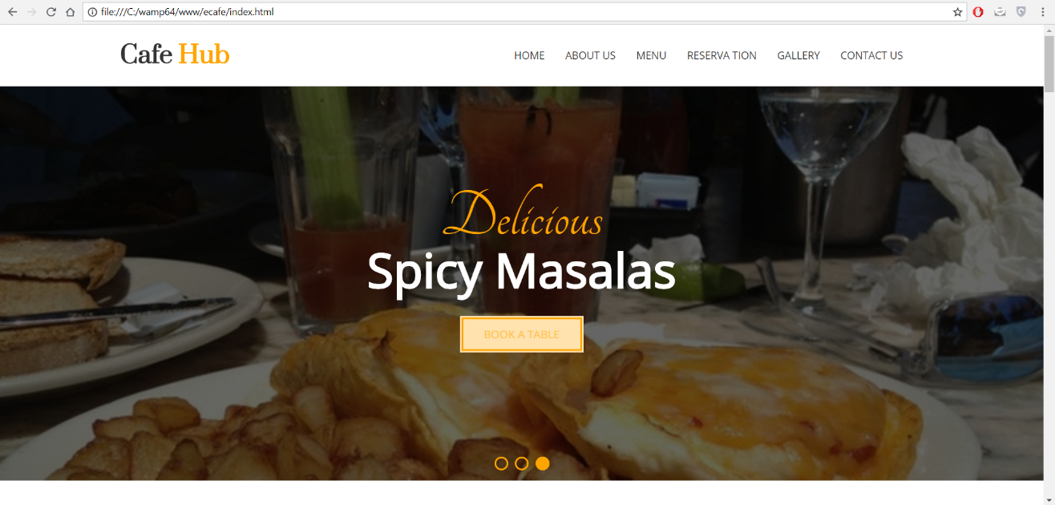

**Homepage**

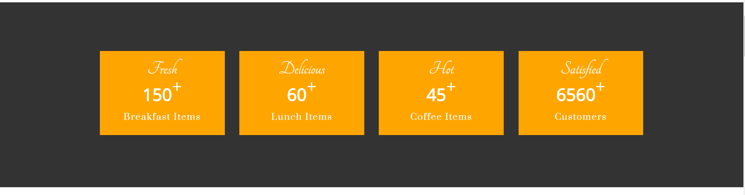

**Statistics**

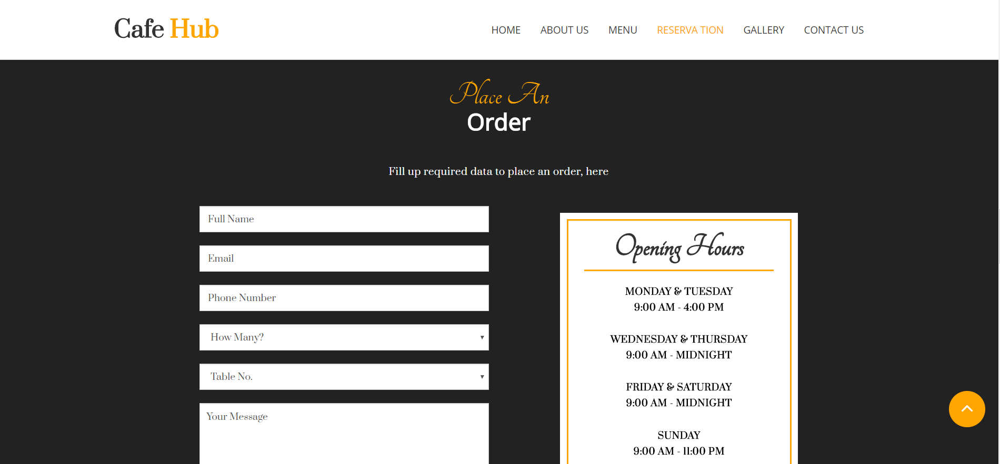

**Order**

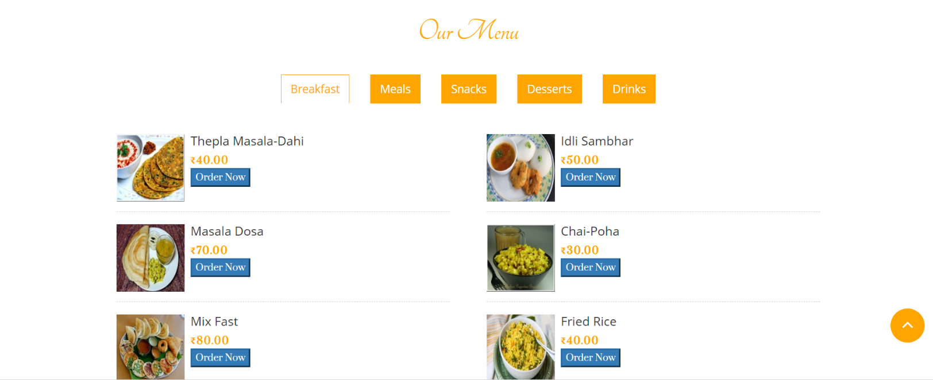

**Our menu**

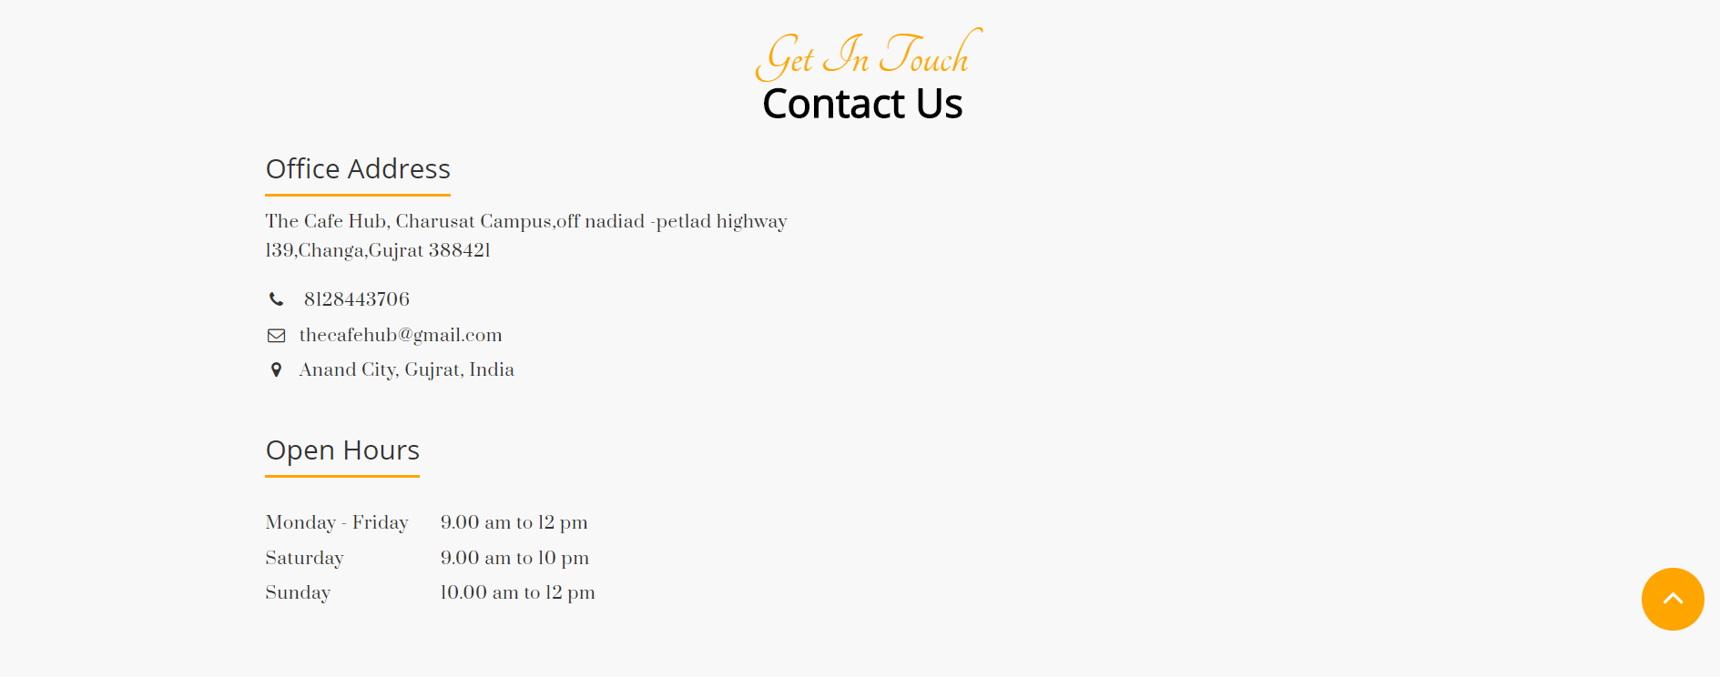

**Contact us**

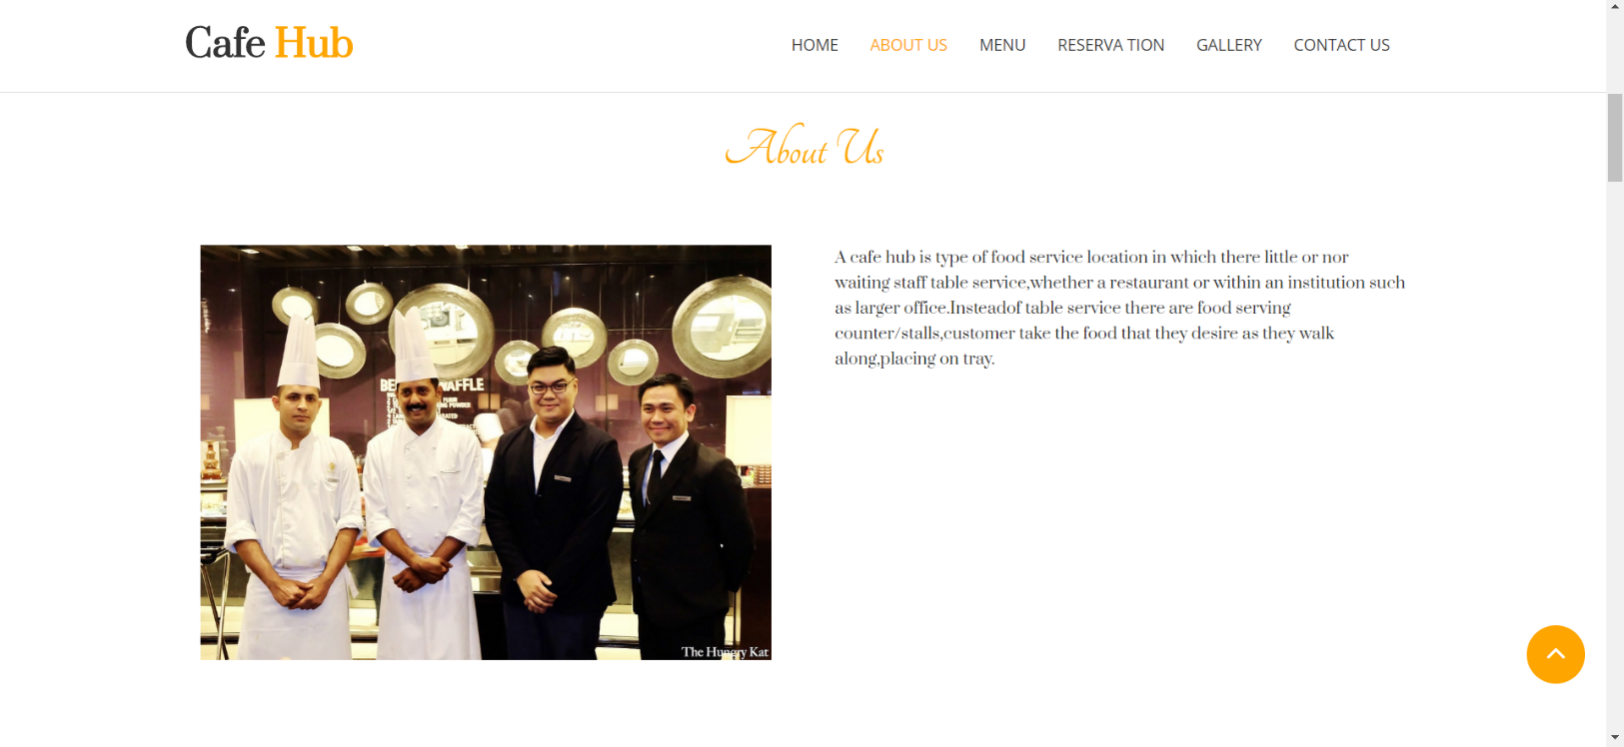

**About us**

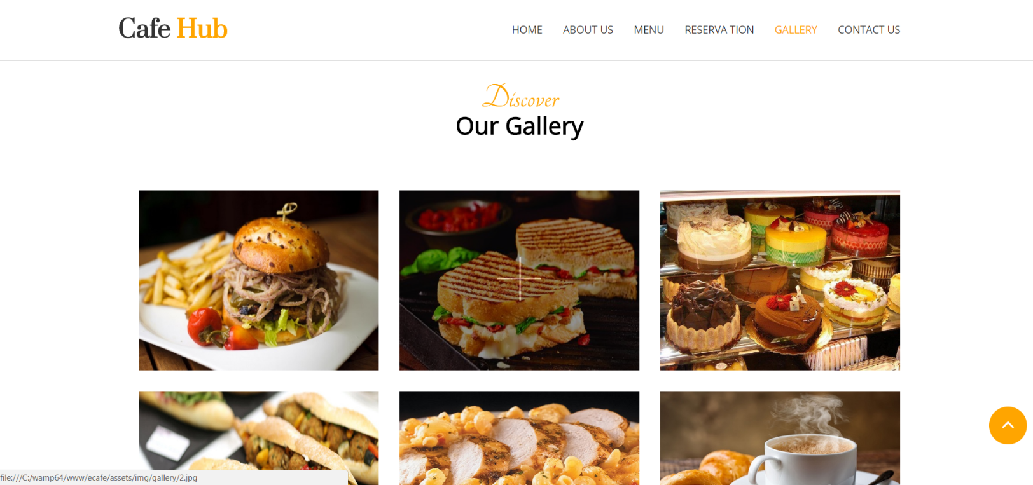

**Gallery**

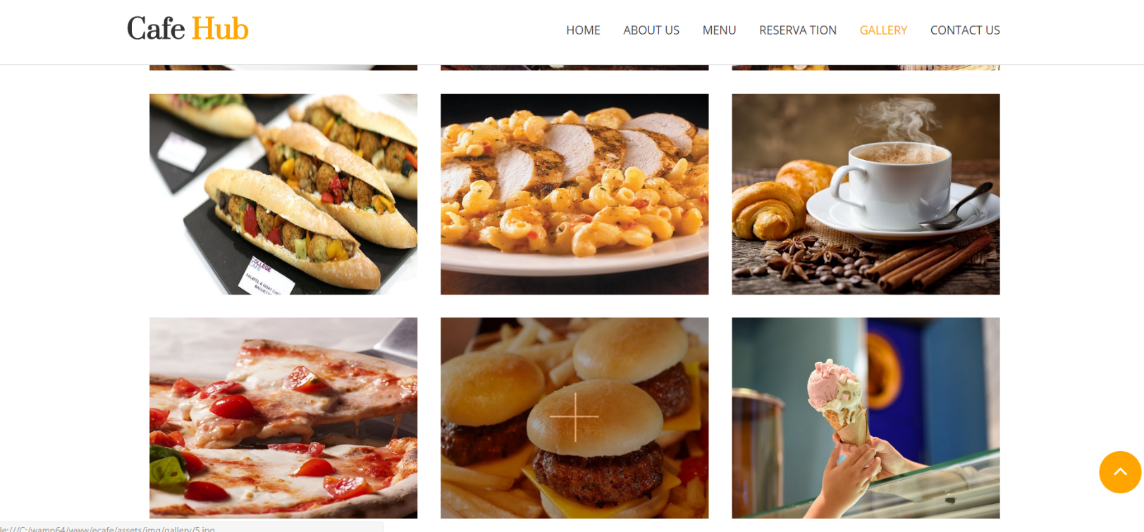

**Gallery**

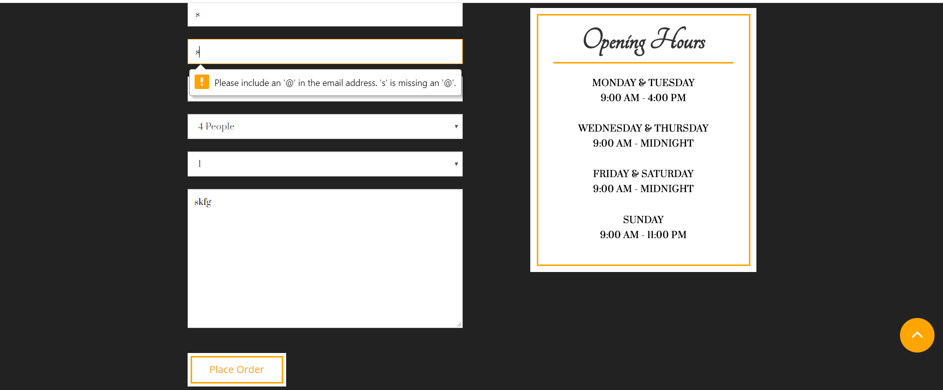

**Place order**

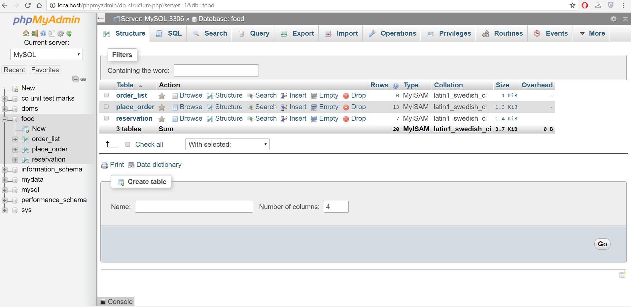

**Database structure**

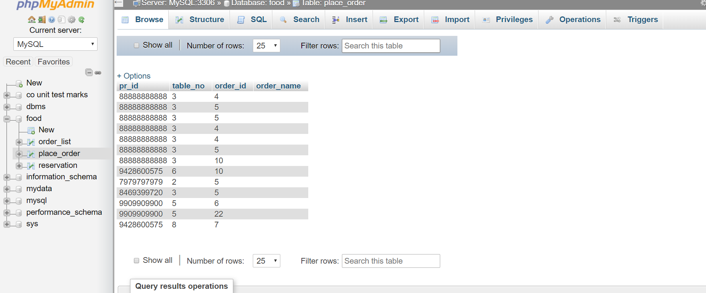

**Order place requests**

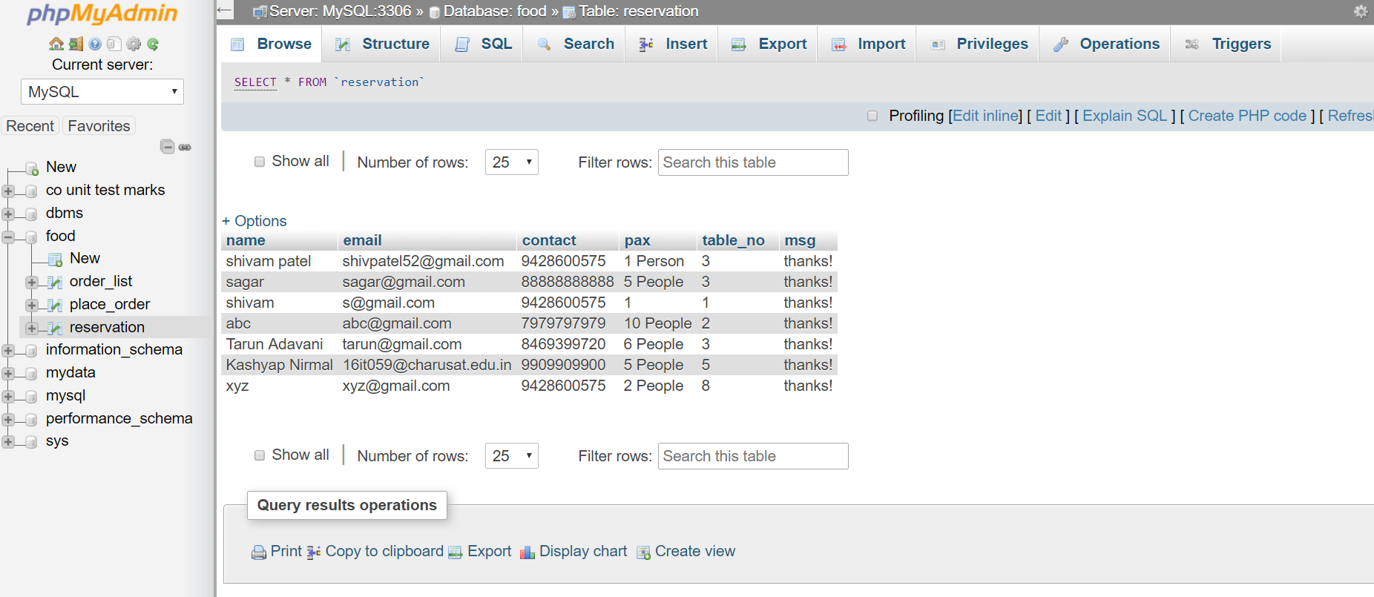

**Table reservation requests**

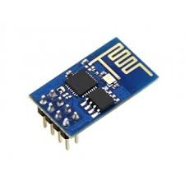

**Wi-fi module (esp8266)**

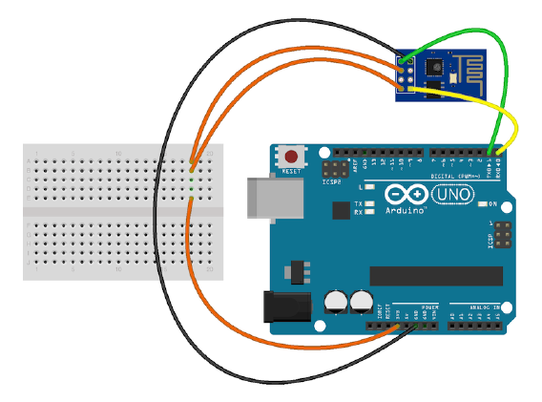

**Connection of Wi-fi module (esp8266)**

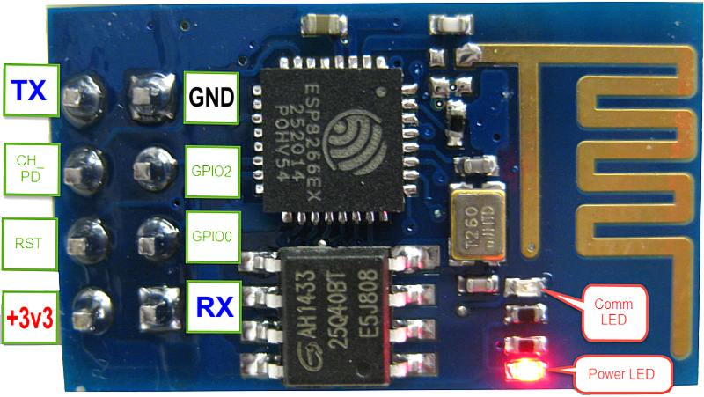

**Esp8266 pinout**

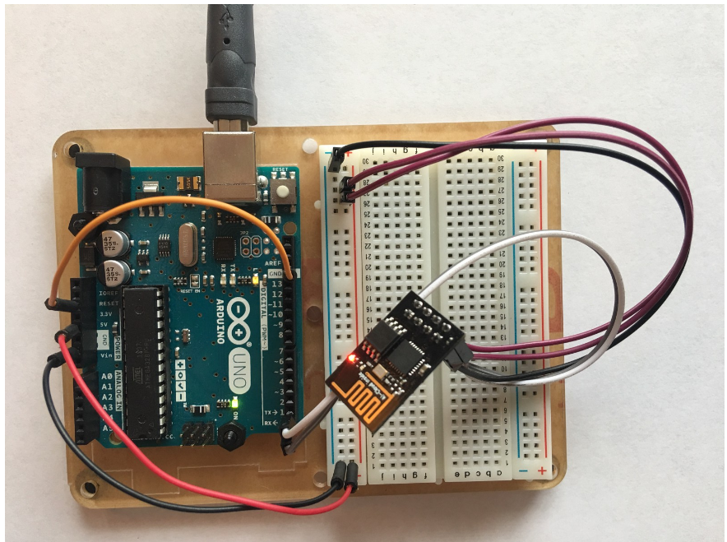

**Wifi-module connection with arduino**

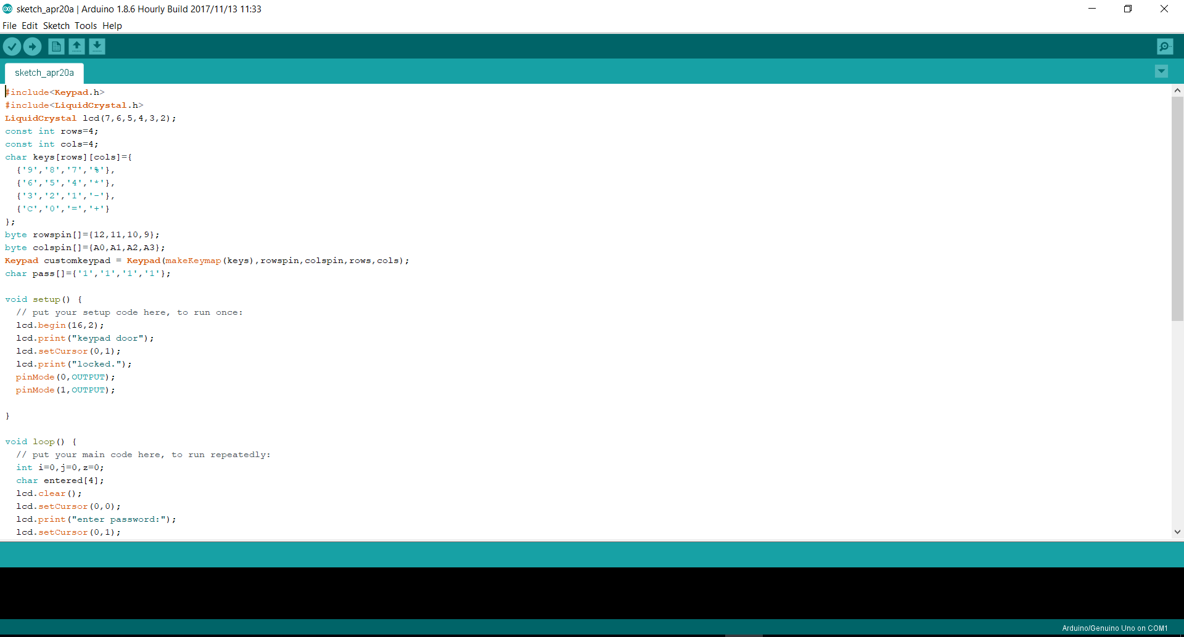

**C code logic for digital door lock**

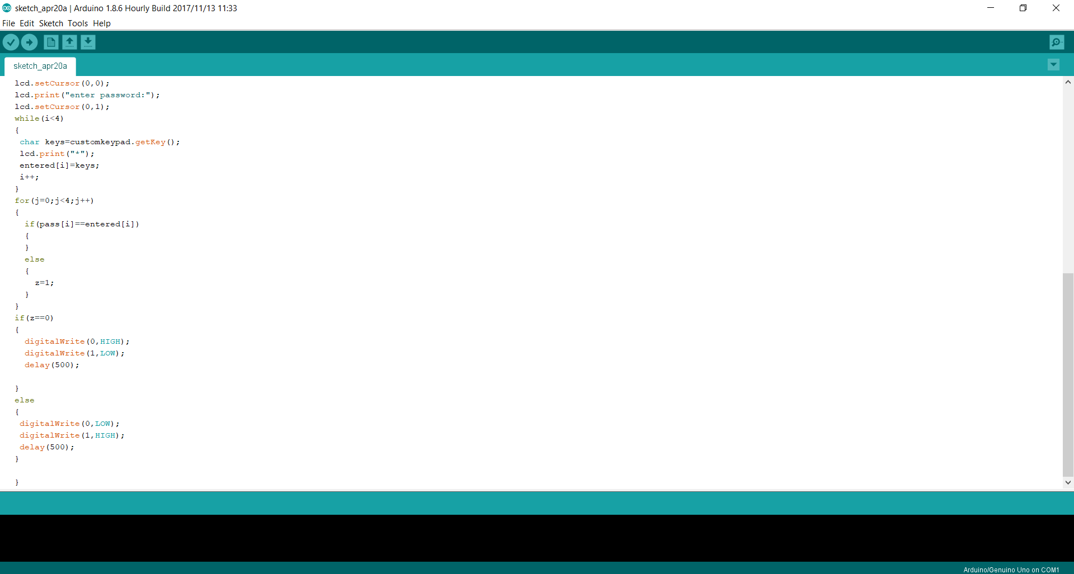

**C code logic for digital door lock**

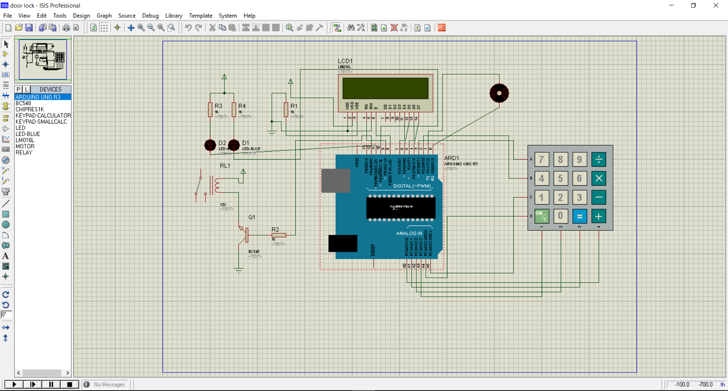

**Design of Digital door lock with virtual connection**

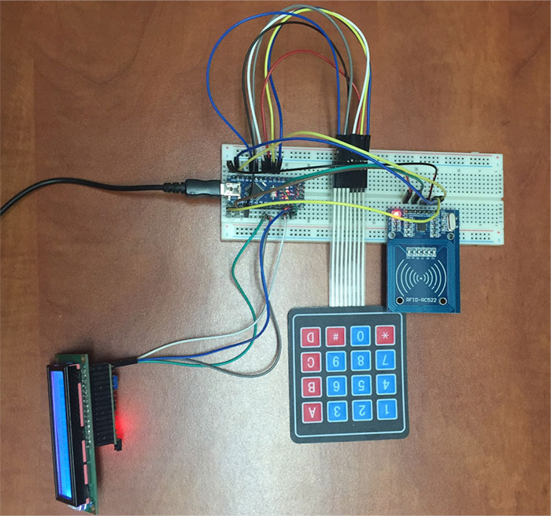

**Digital door lock connection**

**6. CONCLUSION & LIMITATION**

**6.1 LIMITATION OF THE STUDY**

* Due to constraint of time, other web designing tools like Core Java, Code Igniter and Word Press could not be explored.
* Due to our initial limited knowledge on PHP, and barely any on JQuery and Ajax, the subjects had to be well studied before operating upon.
* Due to very limited knowledge on IOT we couldn’t try our hands on making of IOT switches.
* Due to time constraint, even we couldn’t do more exploration on the Wi-fi modules.

**6.2 CONCLUSION OF THE STUDY**

* There are many reasons building a website requires that we obtain the right tools and resources.
* Standardization is one factor. When we use the right tools, we are assured that our pages would be standard and acceptable to every visitor.
* By using standard resources and tools, our visitors are able to view our web pages no matter what browser they use. Our pages would load faster and we would also be able to maintain the pages we have created with ease.
* Time is the one of the most important factor so keeping it in a mind, we should develop such website where rendering time is least so that the visitors doesn’t have to wait much to load a webpage.
* The right resources also make it easy for surfers to use our site. The standard tools used for creating the website will ensure that things such as navigation, menus and layout conform to current practices with which every web user is familiar with.
* Our pages become attractive if we use the right tools. They can display correctly in the browser and your visitors would be glad to visit again because you appealed to them.
* From the basic study of PHP and other scripting languages and tools I now have a clear understanding about creating a database driven website.
* We learn basics of IOT from Wi-fi module.
* We used Wi-fi module to send data in heterogeneous environment.

**7. APPLICATIONS**

The website I worked on can easily suit the needs of a client. It can be used for any of the following type of

* Hotel booking
* Motel booking
* Restaurant booking
* Trip booking
* Holiday booking
* Amusement park booking
* Movie ticket booking

The design and coding which I have done using Arduino can be used in any of the door to protect.

It is a digital lock with 4-digit password protection that ensures no one is allowed except who has the correct password. It has a relay connected with a DC motor which ensures that when the correct password is inserted in matrix keypad then only the motor is provided with +5v supply to rotate the motor so that it allows door to open else power supply is not allowed to lock so it cannot open the door.

We used Wi-fi module to send data in heterogeneous environment say switching ON/OFF lights of the room.

Using Wi-fi module(esp8266) we can create external Wi-fi and hotspot.

**8. REFERENCES**

* [www.bootstrap.com](http://www.bootstrap.com)
* [www.w3schools.com](http://www.w3schools.com)
* <https://ionicframework.com/>
* <https://en.wikipedia.org/wiki/Ionic_(mobile_app_framework)>
* <https://ionicframework.com/framework>
* [www.arduino.cc](http://www.arduino.cc)
* <https://www.arduino.cc/en/Main/Software>?
* <https://store.arduino.cc/>
* <https://www.arduino.cc/en/Guide/Introduction>
* [www.proteus.com](http://www.proteus.com)
* [www.labcenter.com](http://www.labcenter.com)
* <https://en.wikipedia.org/wiki/Proteus_Design_Suite>
* [www.incitesolvents.com](http://www.incitesolvents.com)
* [http://bbs.espressif.com/](http://bbs.espressif.com/-Espressif8266X)
* [Espressif8266X](http://bbs.espressif.com/-Espressif8266X) Datasheet Version 4.3 Espressif System IOT team
* ESP8266 AT Instruction set Version 2.1.0